AI in Production

Slides for the course

This time I used Google Slides to make the materials, so I can easily share them directly! Here are links to all the materials.

It would be tacky for me to use this moment to mention that I welcome LinkedIn connections.
But that’s never stopped me before 😂 https://www.linkedin.com/in/eddonner/

GitHub Repo Link for all codes and structured steps:
https://github.com/ed-donner/production/tree/main

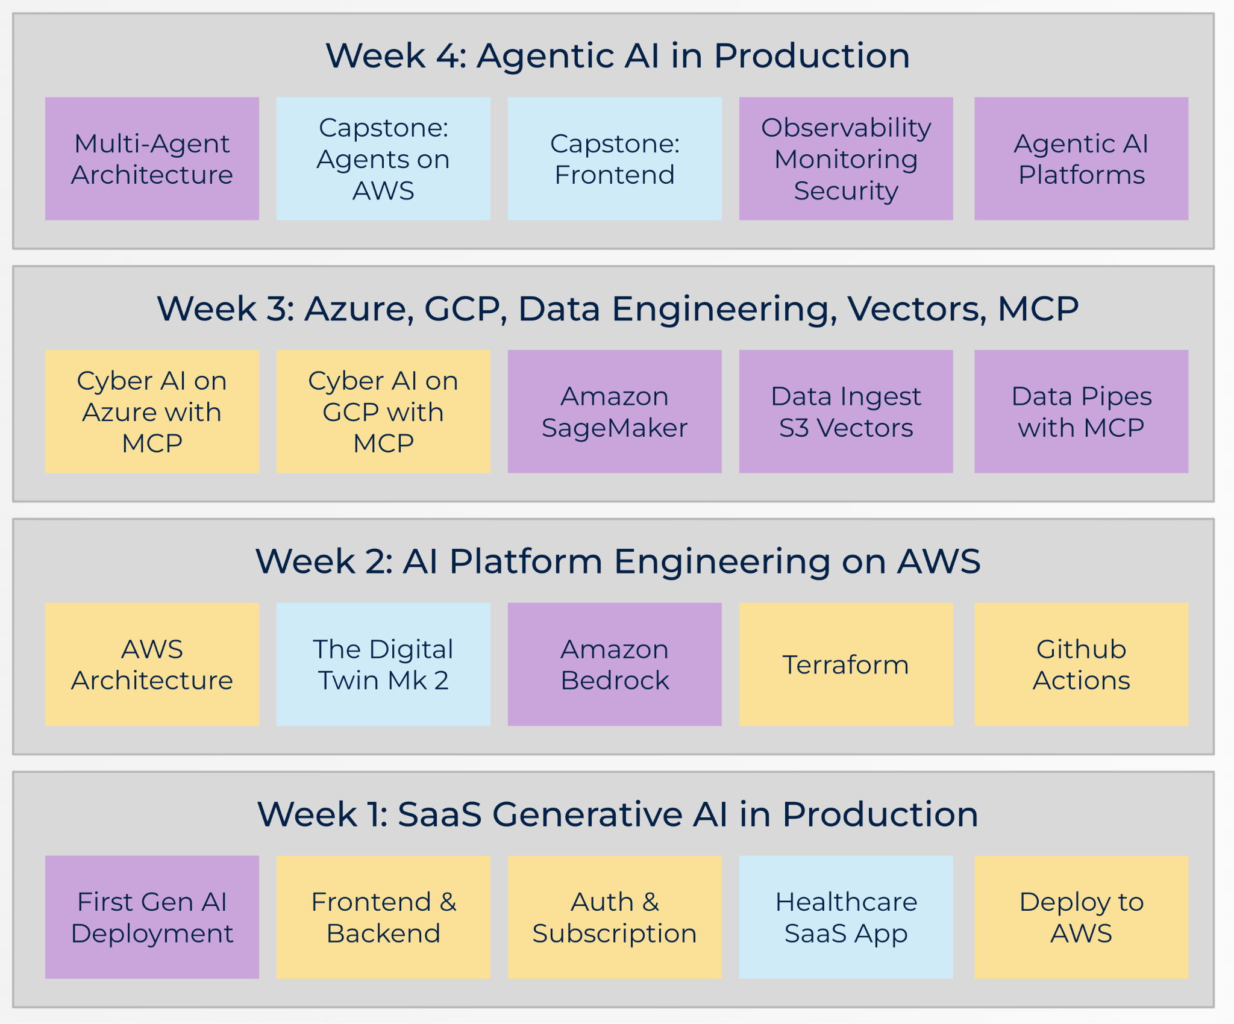

Week 1
Production W1D1
Production W1D2
Production W1D3
Production W1D4
Production W1D5

Week 2
Production W2D1
Production W2D2
Production W2D3
Production W2D4
Production W2D5

Week 3
Production W3D1
Production W3D2
Production W3D3
Production W3D4
Production W3D5

Week 4
Production W4D1
Production W4D2
Production W4D3
Production W4D4
Production W4D5

